Ann Wang
Research PI: Dr. Alexandros Labrinidis
CS1950 Directed Research Capstone
December 8th, 2023

CS1950 Final Paper: PittSmartLiving and LifeSaver Hub

- Introduction
Since May of 2023, I have been working with Dr. Alexandros Labrinidis at the University of Pittsburgh on two research projects: PittSmartLiving and LifeSaver Hub. My CS1950 Capstone is based on these two projects. PittSmartLiving seeks to understand the benefits of providing available real-time multimodal transportation information to Pittsburgh commuters. LifeSaver Hub is centered on developing an automated and computerized system to streamline the process of scheduling lifesaving training events, such as bystander or layperson CPR (bCPR), for the University of Pittsburgh Center for Cardiac Arrest Survival (CCAS). In this paper, I will first discuss the background of these projects, then I will detail my contributions, the implementations, and their outcomes, and finally I will reflect on my overall experience.

- Background
PittSmartLiving is a research project that began in 2016 to evaluate the benefits of providing real-time multimodal transportation information to Pittsburgh commuters. This project aims to increase the utilization and quality of public transportation options (e.g. city buses, Pitt and UPMC shuttles, city bikes) as part of an effort to shift away from the usage of private automobiles and towards more sustainable urban commuting options, as well as to provide a transit-based marketplace for local businesses to promote themselves, such as with time-sensitive discounts to rebalance transit crowding during rush hours (e.g. “The next bus is full - come enjoy a $1 coffee!”). In 2017, PittSmartLiving received a $1.44 million NSF grant to design, develop, deploy, and evaluate a marketplace and mobile app for multimodal transportation. This research group was also responsible for installing several public digital screens around the city that currently aggregate multimodal transportation information. The digital screens component of the project seeks to “democratize” public transportation by making it easier for passersby to find nearby commuting options, regardless of whether or not they have a smartphone with all of the right apps.
LifeSaver Hub is a recent initiative; partnering with the University of Pittsburgh Center for Cardiac Arrest Survival (CCAS), we are working on developing a web portal to streamline scheduling, staffing, and resourcing training events for lifesaving skills, such as bystander or layperson CPR (bCPR). Since early 2023, the CCAS has been organizing these trainings around the community in response to the approximately 91% mortality rate from out of hospital cardiac arrest (OOHCA) in the United States. However, done manually, the process is slow and convoluted. The prototype of LifeSaver Hub is currently still being developed.

- Contributions
The PittSmartLiving project is a contribution to a larger global effort to create sustainable smart cities. By encouraging the use of mobility options besides private automobiles, this research group seeks to reduce the negative impacts of cars on urban environments. This project also aims to improve the current state of Pittsburgh’s public transportation system by informing commuters of when and where they can “catch a ride” in an efficient and consolidated manner. My contribution to the PittSmartLiving project was centered on creating dynamic maps with real-time information about nearby multimodal mobility options, to be displayed on our digital screens around Pittsburgh. These maps not only display locations of nearby bus stations and POGOH bike stations, but they also show updates on upcoming bus arrivals and bike availability. We hope to soon feature other commuting options as well.
The goal of the LifeSaver Hub project is to improve the speed and ease of organizing CCAS lifesaving skills training events. Currently, administrators at the CCAS schedule trainings through phone and email, keeping track of all of their information on a spreadsheet. By streamlining this process through a web portal, LifeSaver Hub will provide the CCAS with a new, more efficient method for accomplishing these tasks. While working on LifeSaver Hub, I was responsible for developing the first prototype. This prototype collects and stores information on trainers and training requests from the community, displays events on a calendar, simplifies assigning trainers to events, and consolidates necessary forms in one place. The final step for designing this prototype will include implementing a secure authentication system, separating administrator, trainer, and event requester user types.

- Implementation
The PittSmartLiving map application was built using a Flask framework. Each PittSmartLiving digital screen location corresponds to several different pages: a map page, a page that flips between a map and a full screen of bus arrival information, a page containing nearby bus information in JSON format, and a page containing nearby POGOH bike station information in JSON format. The bus JSON data feed organizes data from Pitt’s bus arrival API, and the bike JSON data feed does so from the Pittsburgh public bike system’s API. These data feeds were used to display relevant information on the map. HTML, CSS, and JavaScript were used as the main web development tools. The MapBox API was used for the map display. The map display updates its information every 30 seconds.
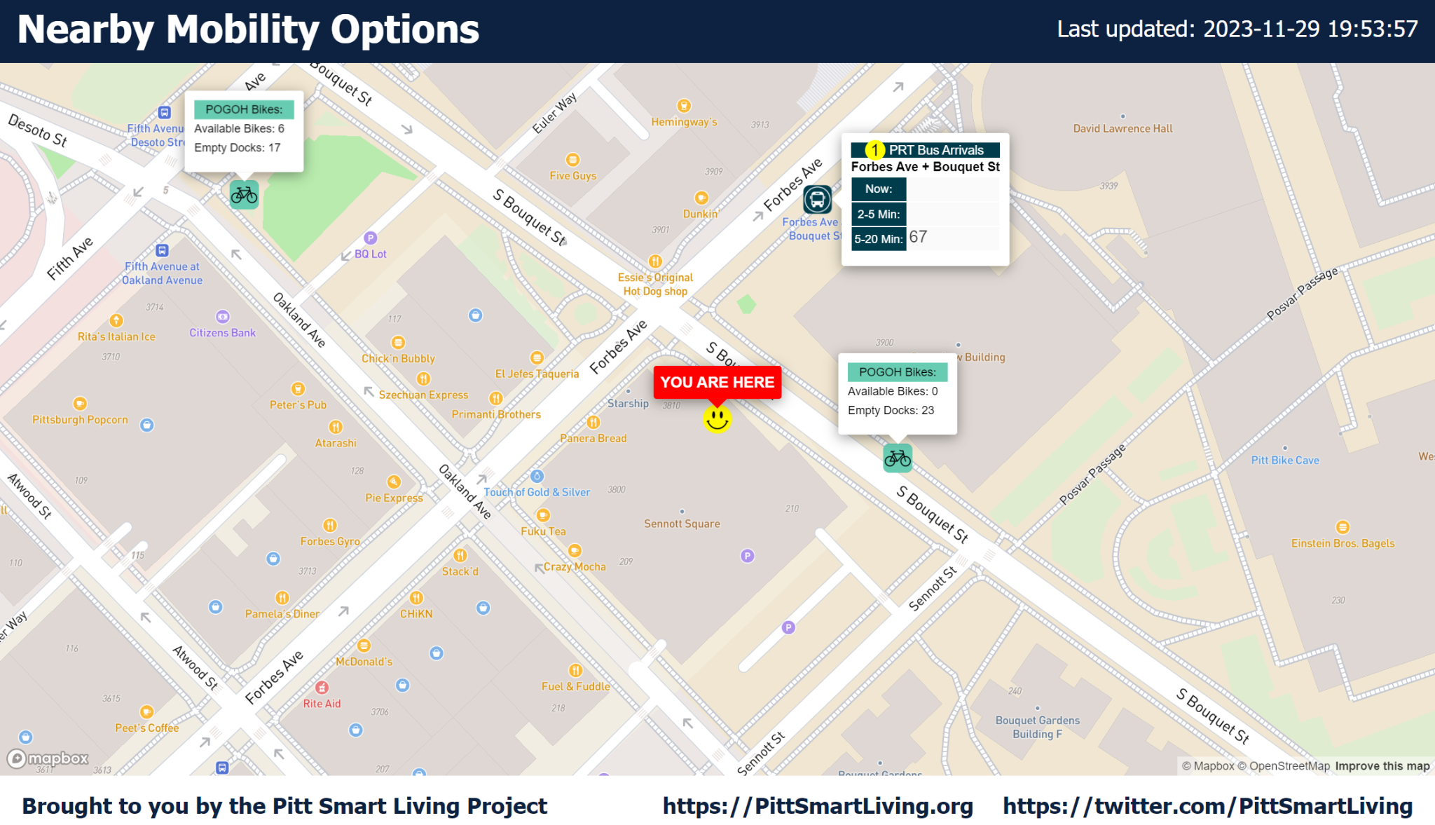
Fig. 1. The PittSmartLiving map application.

The main challenge of working on PittSmartLiving had to do with styling and figuring out how to condense a large amount of information into one visually-appealing and comprehensible page at a time. I worked with Dr. Labrinidis to make decisions on visuals, such as what information was necessary to display and what colors and font sizes would be best suited for our purposes. For bus stations, we decided to only display the bus numbers arriving in <2 minutes, 2-5 minutes, and 5-20 minutes. Other bus arrival details are shown by alternating between the map and a separate detailed bus arrival information screen, which are already deployed and put on display by PittSmartLiving (e.g. https://astro.cs.pitt.edu/arrivals/v2/jcc-forbes-murray2?capacity=live). For POGOH bike stations, we decided to only display how many bikes are available and how many docks are available. We selected certain colors based on the palettes of the transportation companies that are featured, and others based on vibrancy/visibility. We selected font sizes by viewing the page on a screen with the same dimensions as our public displays, and gauging how far away from the screen we could stand while still being able to read the text.
The LifeSaver Hub prototype was also built using a Flask framework. SQLite was used as the database engine to store information on users, trainers, training event requests from the community, and assignments of trainers to training events. The FullCalendar JavaScript library was used to render a calendar and display event dates on it. HTML, CSS, and JavaScript were used as the main web development tools. The prototype includes a dashboard page for event scheduling, a page for trainer information, a page for trainers to submit their information, and a page for people to submit training requests.
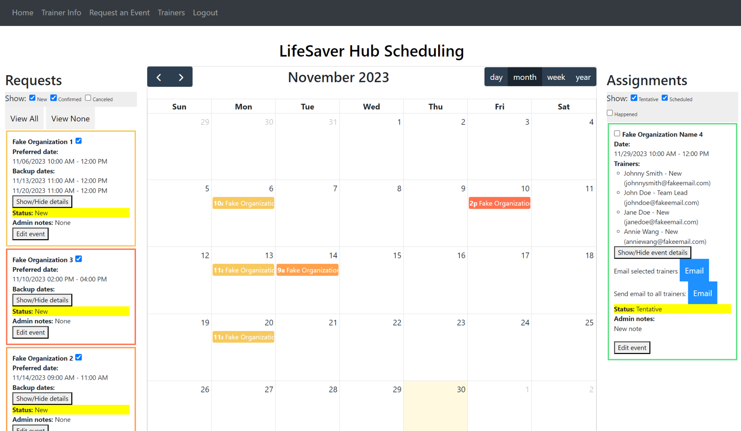
Fig. 2. The LifeSaver Hub initial prototype.

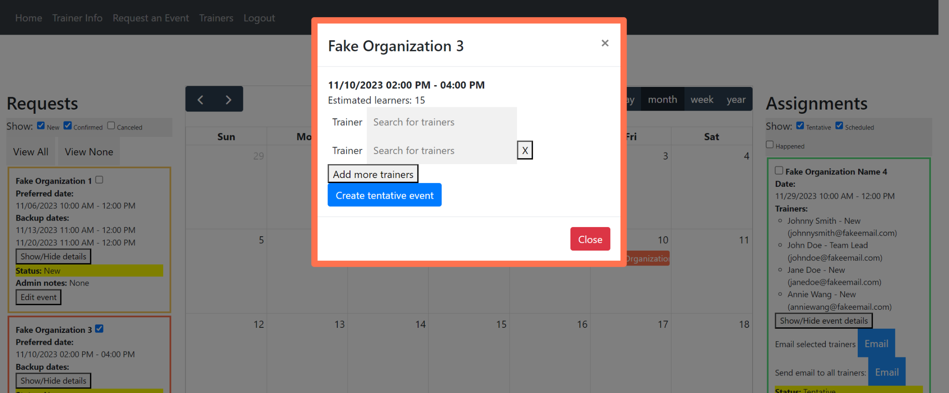
The challenges that I had to address with the LifeSaver Hub application were plenty. I first had to figure out how to collect and store all of my information, which I did using HTML forms and SQLite/SQLAlchemy. As for adding helpful visual components for users, I used the FullCalendar library to create an interactive calendar on the scheduling page. I also needed to figure out how to authenticate and authorize users. I templated the app’s user authentication system using Flask’s login manager, however, its current state is still insecure and will need further work. The main challenge of this project dealt with allowing administrators to take training event requests and assign trainers to them. Each event request goes through several stages. A new event request is immediately assigned the status “New.” After the requester is contacted to confirm the request, the administrator may update the status to “Confirmed.” The administrator can assign trainers to requests by clicking on the request on the calendar, which will pull up an HTML modal that includes autocomplete search bars that parse the system’s list of trainers.
Fig. 2. In LifeSaver Hub, administrators may assign trainers to training event requests using autocomplete search bars. The default number of trainer slots depends on the approximate number of learners at the event, provided by the requester.

Once trainers are assigned, the event request status automatically changes to “Tentative,” and the assignments are displayed on the right-hand column. Administrators may then send an email to the selected trainers. Once those trainers confirm, the event status will be changed to “Scheduled.”

- Outcome
Neither the PittSmartLiving map application nor LifeSaver Hub have been deployed yet. However, most fundamental functionality has been implemented. The current state of the PittSmartLiving map app displays real-time bus and POGOH bike information, updating every 30 seconds. Its development is currently halted, as we are waiting to retrieve information about screen locations and possible other mobility options besides city buses and POGOH bikes. Once the app is deployed on our public digital screens, its success in making it easier for passersby to identify locations and statuses of nearby mobility options could be evaluated by examining changes in transit crowding in those areas. The success of the app would have important implications for how to increase public transportation utilization in sustainable smart cities.
The current state of LifeSaver Hub simplifies and consolidates the process of scheduling CCAS training events into one app. However, before we deploy this app, we would like to implement a more secure user authorization system to separate administrator permissions from other user permissions. We would also like to implement a more automated method of confirming events and trainer assignments, as well as a way to efficiently collect trainer availabilities and apply them to trainer searches. We aim to design this system to initially be used institutionally by the University of Pittsburgh and UPMC, but we hope to make it generalizable to external parties. The success of this app will be evaluated based on real user experiences by the CCAC.

- Issues and Reflections
The PittSmartLiving map application was my first real experience with web development. I was familiar with Python, but only had some knowledge on HTML, CSS, and JavaScript. I had also never worked with a framework before. When I joined this project, I was given the code to a map app for PittSmartLiving that had already been written, but I had to redesign it. Being given the template allowed me to understand how each tool and language was used, and how each file interacted with one another. The time I spent on this app gave me a familiarity with web development skills that I would later use to begin building the LifeSaver Hub prototype.
Similarly, LifeSaver Hub has strengthened my familiarity with web programming. It was also my first experience working with a database engine. Additionally, it gave me the opportunity to learn how to build an app from the ground up. This project involved and will continue to involve collecting input from future end-users (CCAC administrators) as part of the development process, which is a component that is also new to me.
Overall, my experience working with Dr. Alexandros Labrinidis has helped me learn fundamental aspects of the web development process. My main struggles with these projects mostly had to do with my lack of experience, which resulted in fairly slow development. However, my fluency is detectably increasing, and I feel prepared to pursue other web design projects. I am deeply grateful to Dr. Alexandros Labrinidis for providing me with these opportunities and I look forward to continuing working with him in the future.

